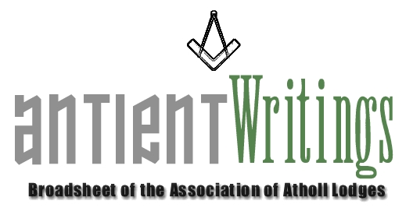

2nd Edition, 2007

Subscription Rates Reduced !

The Subscription rates have been REDUCED for 2008. To assist lodges with ever tighter finances the Association has decided to reduce its annual subscription rate to £7 for all categories, with the exception of Individual membership which will remain unchanged at £5. On the reverse of this broadsheet is an application form for membership. If you have not renewed or would like to join the Atholl family please complete and submit the enclosed form to our Membership Secretary, Rod Letherby.

A Brothers Assistant – The Laurence Dermott Story

The 40 page illustrated book is still available, telling the story of Laurence Dermott. If you would like a copy please contact the Secretary. They are £6 inc P & P [UK]

Annual General Meeting

The 2007 Annual General Meeting was held at FM Hall Great Queen Street London on Wed 4th July. The Chairman reported a successful year with many visits and a successful outcome to the celebrations to remember Laurence Dermott and his Constitution, Ahiman Rezon.

New Hope – Rescue a Lodge

If you are a struggling Atholl lodge bereft of members facing the stark reality of erasure – don’t despair. The Secretary is aware of a group of ‘Atholl’ enthusiasts who are willing to ‘rescue’ such a lodge rather than let it be lost. The plan would be to enrich its membership and move it to Sindlesham, Berkshire where it would have a safe and secure home and future. Further information is available through a link contact via the Secretary.

Visits

The major event in 2008 will be a visit to our two lodges in Jamaica. The trip is in the planning stages and it is hoped will take place in early May 2008. The costings are being investigated at but a trip of 10 days on this year’s prices flying from Heathrow with hotel accommodation should be in the region of £800-1000 per person. This trip is also a ‘holiday’ break to include your wife/partner. Other events and meeting will be arranged whilst on the island. All are welcome BUT the Secretary would like early indication of numbers. Should you be interested please contact Paul on the number below as soon as possible.

Web Site - www.antients.com

The website has had a make over and Neil, the webmaster is keen to enhance the ‘Regions’ pages to include ‘info’ and ‘chat’ from any Atholls around the country. Please send any submissions to him at: webmaster@antients.com

Midlands Meeting

It has been suggested that one of the Executive meetings be held ‘around the country’ and to that end it is hoped to arrange one for the Midlands sometime in the future. Would any lodge interested in hosting such a meeting please make contact with the Secretary to facilitate planning and maybe give consideration to ‘bolting’ to it some other local event. A talk or meeting perhaps!

New Blood

If you are interested in joining the Executive Committee, which meets 3 times a year in London with the possibility in future of having one meeting out of London? Please make contact with the Secretary who is always keen to involve new blood and share common antient interests with Atholl brethren.

Would Secretaries and Representatives photocopy and distribute as widely as possible

Paul Gardner - 39 Wentworth Drive, Bedford, BEDS, MK41 8QA - 01234 261584 - secretary@antients.com

